Project Design Phase-II

Data Flow Diagram & User Stories

Date | 30 Jan 2026
Team ID | LTVIP2026TMIDS88779
Project Name | Online-Payments-Fraud-Detection-using-Machine-Learning
Maximum Marks | 4 Marks

Data Flow Diagrams:
A Data Flow Diagram (DFD) is a traditional visual representation of the information flows within a system. A neat and clear DFD can depict the right amount of the system requirement graphically. It shows how data enters and leaves the system, what changes the information, and where data is stored.

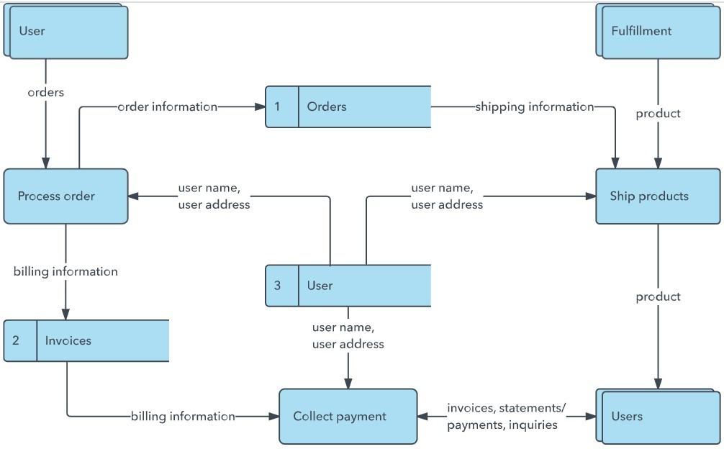
Example: DFD Level 0 (Industry Standard)

Example: (Simplified)
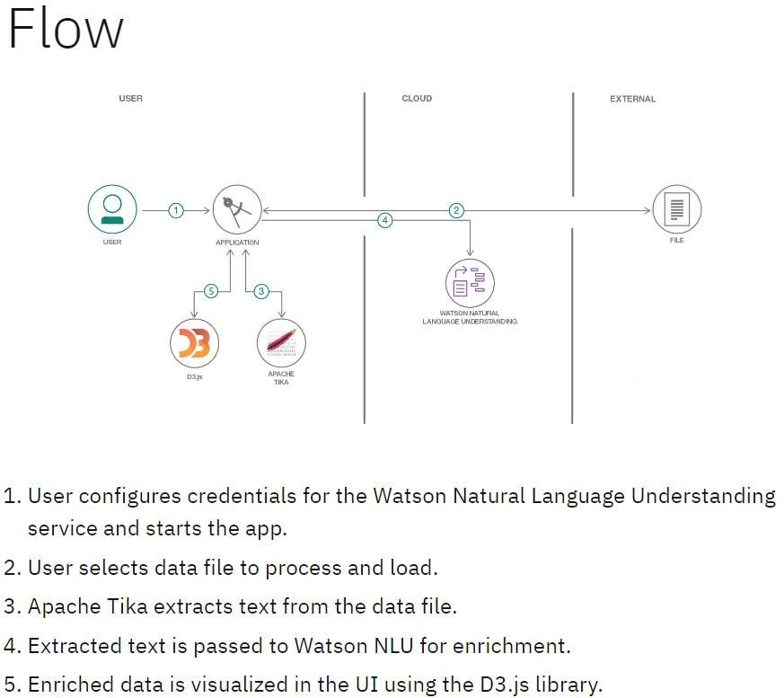

User Stories
Use the below template to list all the user stories for the product.

User Type | Functional Requirement  (Epic) | User Story No | User Story / Task | Acceptance Criteria | Priority | Release
Customer (Mobile) | Registration | USN-1 | As a user, I can register using email & password. | User can access dashboard after registration. | High | Sprint-1
Customer (Mobile) | Registration | USN-2 | As a user, I receive a confirmation email  after registration. | User receives & verifies  email. | High | Sprint-1
Customer (Mobile) | Login | USN-3 | As a user, I can register using Google account. | User can login via Google. | High | Sprint-1
Customer (Mobile) | Login | USN-4 | As a user, I can login using email & password. | User successfully logs in. | High | Sprint-1
 |  | USN-5 | As a user, I can reset my password if forgotten. | Password reset link is sent to email. | High | Sprint-1
Customer (Mobile) | Dashboard | USN-6 | As a user, I can view predicted wind energy output. | Prediction data is displayed clearly. | High | Sprint-1
Admin | Analytics | USN-7 | As a user, I can view weather parameters  (wind speed, temperature, humidity). | Weather data is  displayed. | High | Sprint-1
 |  | USN-8 | As a user, I can view prediction charts & graphs. | Graphs load correctly. | Medium | Sprint-2
 | Alerts | USN-9 | As a user, I receive alerts when wind  energy production is high/low. | Notifications are  delivered. | Medium | Sprint-2
Customer (Web) | Login | USN-10 | As a web user, I can login securely. | User dashboard loads. | High | Sprint-1
 | Dashboard | USN-11 | As a user, I can view wind energy prediction reports. | Reports display correctly. | High | Sprint-1
 |  | USN-12 | As a user, I can download prediction reports. | File downloads successfully. | Medium | Sprint-2

